Outfitter Guide
Outfitter is a Maya 2026 tool for dressing character rigs. Browse a shared library of clothing, snap a garment onto your animated character in one click, and take it off just as cleanly. Made something new? The tool walks you through publishing it back to the library so everyone can use it.
It runs as a single window with three tabs: Library (browse and attach), Publish (turn a garment you built into a library asset), and Setup (where your library lives).
GenHuman v03 comes registered out of the box. Working with a different rig? Register it once (see Working with rigs) and everything else behaves the same.

1. How it works
Every garment is a mesh skinned to its own copy of the rig’s skeleton - the cloth_* joints. Attaching does exactly one thing: it connects each body joint to the garment joint with the matching name (spine_03 drives cloth_spine_03), translate, rotate and scale.
- The match is by name. If something doesn’t follow the body, check joint names first.
- No constraints, utility nodes, expressions or driven keys are ever created, and the rig itself is never modified. A dressed scene exports exactly as the bare rig would (see Genie export).
- You can wear several garments at once. Each one sits in its own namespace (e.g. coat:), and Detach removes only that garment and the connections the tool made.
- Helper joints you add to a garment (coat tails, skirts, straps) are not connected. They stay free for the animator.

2. Install and setup

Install
- Unzip the distribution somewhere, keeping its layout intact.
- Drag install.py from a file browser into a Maya 2026 viewport.
- Outfitter copies itself in, merges a starter set of assets into your library (without overwriting anything you already have), and adds an Outfitter button to the shelf you have open. A dialog confirms what it did.
Click that shelf button any time to open the window. You can also launch it from the Script Editor (Python):
import outfitter.launch
outfitter.launch.run()
Dropping install.py again later upgrades the tool. The package is replaced; your assets and library folders are kept.

Point it at your library (Setup tab)
On Setup you set two folders:
- Local (working): your copy of the library, on your machine or a fast drive. This is the only folder Outfitter scans - you browse and attach from here.
- Remote (master): the shared studio library on a server or network drive. It is never scanned. Publishing writes to it, and Sync pulls from it.
Use Browse… to pick each folder, or Clear to unset it. Both are saved in a small text file, path.txt, beside the installed package. It survives upgrades, and you can edit it by hand if you prefer:
local = D:/clothing_library
remote = //studio-nas/projects/genhuman/clothing
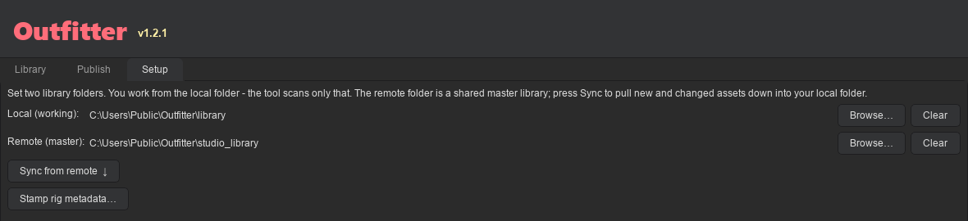
The Setup tab, with the local and remote library folders set
With no local folder set, Outfitter falls back to its built-in library. No remote? Outfitter runs happily on just the local folder (but you need one to publish). A folder shown as (missing) isn’t reachable right now, usually because the drive or server isn’t mounted.

Sync from the master library
Click Sync from remote ↓ to pull the latest assets down into your local folder. Sync is one-way, and apart from deleted assets it only ever adds and updates:
- New assets on the remote are copied down. Assets that changed on the remote (different size or newer) replace your local copy.
- Assets you made locally are always kept.
- A file you edited locally more recently than the remote copy is left alone.
- An asset someone deleted from the library (see Delete a garment) is moved to your trash - unless you edited it after it was deleted, in which case it stays.
You get a one-line summary (e.g. “Sync complete - 3 added, 1 updated, 12 up to date.”) and the Library refreshes. The button is greyed out until both folders are set. The Refresh button at the top of the window also pulls from the remote first.

3. Working with rigs
At the top of the Library and Publish tabs is a Rig dropdown. It answers “which character am I working with?”, and everything follows from it: the Library shows clothing for that rig, and Publish tags what you make with it. Your choice is remembered between sessions.

Register a new rig
Put the rig in a scene, go to the Publish tab and click Register rig…. Outfitter reads the scene and proposes:
- the export skeleton - the group holding the joints garments will bind to. It lists every candidate it found, biggest first. Pick the right one; this is the skeleton it captures.
- the body variants - the attribute that switches between male and female bodies, if the rig has one. Nothing in a rig says which end of the slider is which body, so if the two come out backwards, click Swap.
- the rig file - the .ma to copy into the shared library so colleagues can fetch it. Confirm it’s the rig itself and not the scene you imported it into.
Click Register. Outfitter captures the skeleton, works out which joints each garment type should skin to, saves the rig profile to the shared library, and selects the new rig. Everyone else picks it up on their next Sync.

Fetch a rig body
Rig files are big, so Sync doesn’t copy them to every machine (it copies only the small rig profiles). Beside the rig dropdown you’ll see where the body is: ready, or not downloaded with its size. It downloads when you first need it (loading a test body) or when you click Fetch rig. Just picking a rig never downloads anything.

Rigs and versions
Every asset records one rig (which rig it’s built for) and the rig versions of that rig it fits. Both are checked before attach. A garment for a different rig is refused outright, because two rigs can share joint names and the garment would attach and then deform into nonsense. If the scene’s rig version can’t be detected, the version check is skipped with a warning instead of blocking you.
Assets published before Outfitter supported multiple rigs carry no rig ID; they’re read as GenHuman assets, so an older library keeps working. Setup ▸ Stamp rig metadata… writes that identity into them explicitly.

Use a garment on a different rig
A garment is skinned to one rig’s skeleton, so it can’t simply be attached to another. Right-click it in the Library and choose Retarget to…. Outfitter opens the asset, renames its joints to the new rig’s, and moves them onto the new rest pose without disturbing your skin weights. It shows you anything it couldn’t map before it starts.
Retargeting does not reshape the garment. If the two rigs are different sizes, the mesh needs a manual refit and probably a weight touch-up. Check the fit on the new body, then publish it under a new name - the original is left alone.

4. Dress a character (Library tab)
The Library tab shows your assets as a grid of thumbnails.
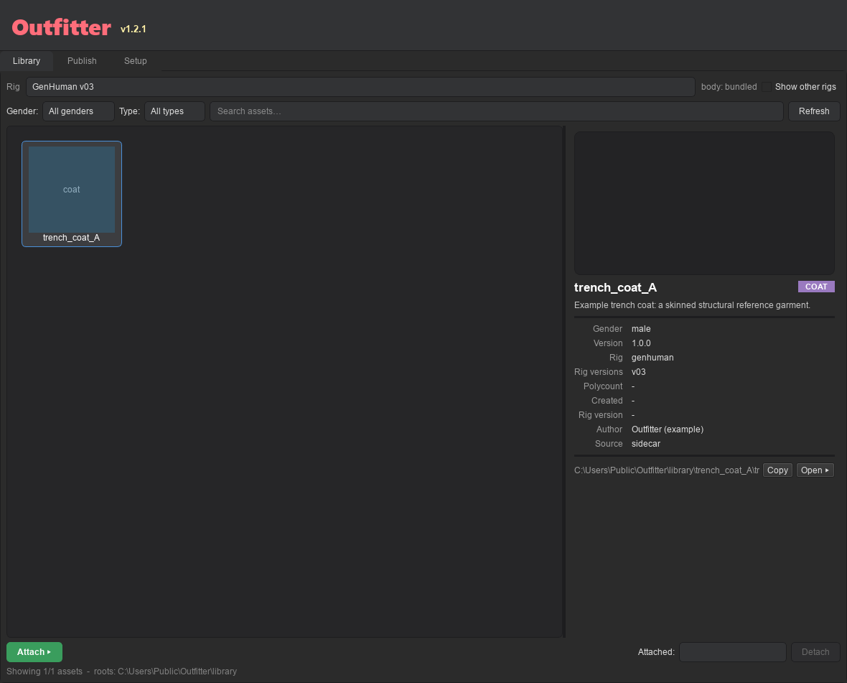
The Library tab with the starter trench coat selected and its details on the right
- Filter by Gender and Type (shoes, pants, shirt, dress, coat, hat), or use the Search box.
- Clothing built for other rigs is hidden. The status line at the bottom counts it, and Show other rigs brings it into view (greyed out, since it can’t be attached here).
- Click an asset to see its details: name, type, version, rig and rig versions, author, path, and any problems. The preview is a live turntable - hover to spin it, or drag left and right.
- Right-click a thumbnail to open its folder, copy its path, refresh its thumbnails, or retarget it.
To dress your character:
- Make sure the rig picked in the Rig dropdown is in your scene. Several rigs in there? Select any node of the one you mean first.
- Select an asset and click Attach ▸. Give the instance a name if asked; it becomes the garment’s namespace.
- Outfitter checks everything first (see Validation error reference). If anything is an error, attach is refused and the scene is left exactly as it was. Warnings don’t block.
- The garment snaps on and follows as you pose and animate. Repeat for more garments, e.g. a shirt, pants and shoes together.
- Done with one? Pick it in the Attached list and click Detach. The rest stay on.

Male and female variants
There is no fit step when you attach. A rig’s body morph moves only the body mesh, not the joints, so a single garment can’t follow the difference between the male and female body on its own. Instead each garment is made twice, hand-fit once on the male body and once on the female body, and those are two separate assets. Pick the variant that matches the body you’re dressing. A rig with a single body has no variants, and its assets record gender none.

5. Make a garment (Publish tab)
Make in: Maya 2026 · Save as: Maya ASCII (.ma)

What you’re making
A clothing asset is your garment mesh, skinned to the rig’s cloth_* joints, in a clean scene. Outfitter builds the joints and the scene structure for you; your job is the mesh, the skinning, and keeping the scene clean. Make each garment twice - once on the male body, once on the female body. By convention they’re named m_<name> and f_<name>.

Prep the mesh
- Pivot at world origin (on the ground), transforms frozen, geo at its correct height. A non-zero pivot height is a handy sign the garment isn’t sitting right on the rig.
- Clean UVs on every mesh. Name meshes cloth_<part>_mesh.
- Smooth bind only. Delete history.
- Generic shader (lambert or standardSurface).
- No blendShapes, no nCloth or simulation, no shrinkWrap to the body.

Keep the scene clean
Create cloth skeleton (Step 1 below) makes the three required groups - Mesh_GRP for meshes, Rig_GRP for the cloth_* joints, Ctrl_GRP for controls - and moves your garment geo into Mesh_GRP. To publish, the scene also needs:
- Bare names - no namespaces, no references, no body rig left in the scene.
- Skin on the cloth_* joints only, never the body rig’s joints.
- Extra controls (for tails, skirts, straps) in Ctrl_GRP.
If the body rig is already in the scene when you build, Outfitter can’t tell your geo from the body mesh, so it leaves Mesh_GRP empty for you to fill.

Step by step
Work straight down the five numbered steps on the Publish tab.
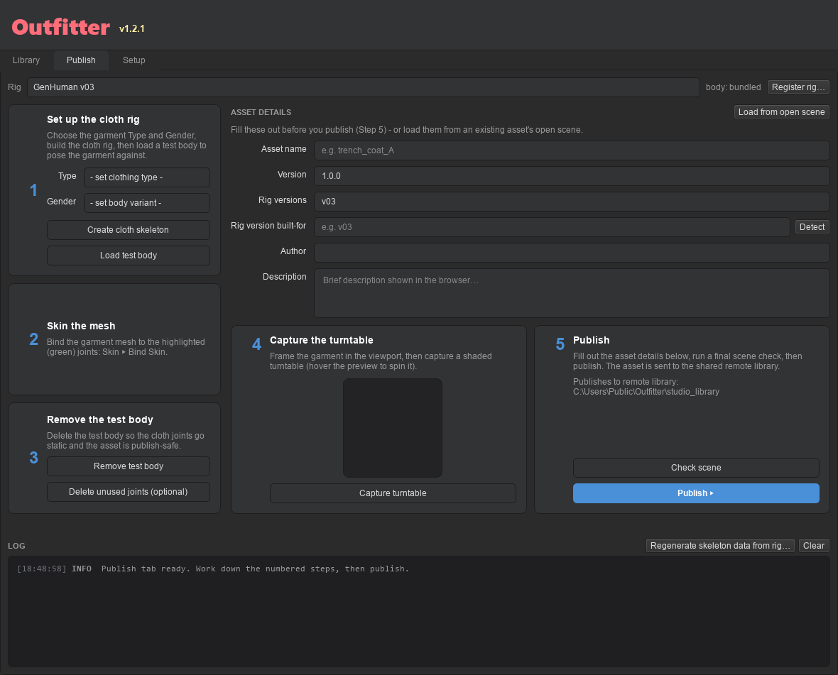
The Publish tab: the five numbered steps, the asset details form, and the log
1. Set up the cloth rig. Check the Rig dropdown is the rig you’re building for, pick the Type and Gender, then click Create cloth skeleton. Outfitter builds the cloth joints, creates the groups, and turns the joints you should skin to green. Click Load test body to bring in the matching body to pose against. (A rig with a single body has no Gender to choose, and the field says so.)
2. Skin the mesh. Bind your garment to the green joints (Skin ▸ Bind Skin). A standard smooth bind, nothing fancy.
3. Remove the test body. Pose the body to check your garment follows nicely, then click Remove test body so the joints go still. (Optional: Delete unused joints to tidy up.)
4. Capture the turntable. Frame your garment in the viewport and click Capture turntable. Outfitter orbits it and bakes a clean, shaded preview, plus a still for the grid thumbnail. Hover it to make sure it looks good.
5. Publish. Fill in the details (asset name, version, rig versions it fits, author, description), click Check scene to catch problems, then click Publish. Outfitter writes the details into the .ma (a cloth_info node) and sends the asset to the shared library, ready for everyone. Publishing needs a remote folder set on the Setup tab.

Final checklist
- Pivot at world origin, transforms frozen, geo at correct height; history deleted; clean UVs.
- Mesh_GRP, Rig_GRP and Ctrl_GRP at the root; bare names; no namespaces or references.
- Skinned to cloth_* joints (smooth bind). No blendShapes, simulation or shrinkWrap.
- Generic shader only.
- Test body removed - no body rig left in the scene.
- Type and Gender set; details filled in.
- Check scene passes.

6. Fix a garment you already published
Spotted a weighting mistake (or anything else) after publishing? Fix it and publish over the top - the library keeps one copy per name, so there is nothing to delete first.
- Open the published .ma from the shared library (<library>/<name>/<name>.ma). It re-opens fully editable: the mesh, the cloth joints, and the skin all survive.
- Fix it - e.g. Paint Skin Weights on the existing skin. Keep the skin on the cloth joints; Check scene flags anything else. To pose-test, Load test body, then Remove test body before publishing.
- On the Publish tab, click Load from open scene. The form fills itself from the details saved inside the asset.
- Keep the name exactly as it is - that is what makes this an update. A new name publishes a second garment alongside the old one.
- Bump the version (say 1.0.0 to 1.0.1) so people can tell the fixed copy apart.
- Check scene, then Publish, and answer Yes when it asks to overwrite.

The overwrite prompt shown when re-publishing under an existing name
Your weights are saved exactly as you painted them; nothing rebuilds the skin. The thumbnail and turntable are regenerated. Two things to know afterwards:
- Everyone else gets the fix on their next Sync (or Refresh).
- Scenes already wearing the old version keep the old weights. Attaching copies the garment into the scene, so those scenes don’t update on their own: Detach the garment and Attach it again from the library.

Update just the thumbnails
Older assets keep whatever thumbnail they shipped with. To give one the shaded still and spinnable turntable without a full re-publish, right-click its thumbnail and choose ↻ Refresh thumbnails. It opens the asset in Maya, recaptures, and overwrites only the two image files - the .ma and its details are untouched. The images go to your local copy and, when a remote library is set and already holds the asset, to the shared copy too. It replaces the current Maya scene, so save your work first.

Rename a garment
Right-click its thumbnail and choose Rename…, then type the new name. The name you type is what the Library shows; the files and folder use a filesystem-safe version of it (spaces become _, as when publishing).
- The asset is renamed in your local library and, when it has been published, in the shared one too. Each copy keeps its own content, so unpublished local edits stay local.
- Everyone else sees the new name on their next Sync (or Refresh); their copy under the old name goes to the trash, just as if it had been deleted (see below).
- The old files are moved to the trash, not destroyed.
- A name already used by another asset is refused - rename never overwrites anything.
- Only the name changes. The garment’s nodes (including its cloth_<name> top group) are untouched, and scenes already wearing it don’t change.

Delete a garment
Right-click its thumbnail and choose Delete…. After you confirm:
- The asset is removed from your local library and, when a remote is set, from the shared one too.
- Everyone else loses it on their next Sync (or Refresh). Anyone who edited their copy after the delete keeps it.
- Nothing is destroyed. Each copy is moved to that library’s _rigs/_trash/ folder, named <name>_<date>-<time>. To undo, move the folder back into the library (the remote copy too) and delete the asset’s marker from the remote’s _deleted/ folder.
- Scenes already wearing the garment don’t change. Detach it there if you want it gone.
Only assets in your own local folder can be deleted, not the built-in starter library. Publishing a garment under a deleted name brings it back for everyone.

7. Genie export
Attaching only connects transform channels and never adds nodes to or changes the rig, so you export the dressed scene normally (.ma, USD, FBX or Alembic). Required rig node names are preserved and the export skeleton is intact. An export-readiness check confirms, before you export, that every connection Outfitter made drives the garment (never the rig) and that the export skeleton still resolves.
Pending from the pipeline team: the exact list of Genie-required node names. Until it arrives, that part of the check never blocks you.

8. Validation error reference
Outfitter validates in three stages. Any error is a hard stop and leaves the scene unchanged; warnings are advisory. Each message names the node at fault and how to fix it. If attach fails for any reason, the scene is rolled back - you never end up with a half-attached garment.

Stage A - the asset file (before anything touches the scene)
Code | Meaning | Fix
no_metadata | No readable cloth_info or sidecar .json, or a required field (incl. gender) is missing or invalid. | Re-publish with all details filled in.
no_info_node | The cloth_info node is missing. | Re-publish from the Publish tab, which adds it.
missing_group | Mesh_GRP, Rig_GRP or Ctrl_GRP is missing. | Create the missing group under the asset’s top group.
no_root_joint | No cloth_root joint. | Rebuild with Create cloth skeleton.
no_cloth_joints | No cloth_ joints found. | Rebuild with Create cloth skeleton.
bad_joint_suffix | A connection joint has a _jnt suffix. | Name = cloth_ + the exact body joint name, no _jnt.
has_references | The asset contains references. | Import or remove all references.
has_namespaces | The asset contains namespaces. | Remove them; Outfitter adds one at attach.
forbidden_node_type | A blendShape, nCloth or nucleus node is present. | Remove it; blendShapes and simulation aren’t supported.
duplicate_name | A node name appears more than once. | Make every node name unique.

Stage B - the scene, just before import
Code | Severity | Meaning | Fix
no_rig | error | The selected rig isn’t in the scene. | Load that rig, or pick the rig that is in the scene.
rig_mismatch | error | The asset was built for a different rig. | Use an asset for this rig, or Retarget to… it.
version_unknown | warning | The scene’s rig version couldn’t be detected. | The version check is skipped, not failed.
version_incompat | error | The asset’s rig versions don’t include this scene’s version. | Use an asset that covers this build of the rig.
ns_in_use / ns_exists | error | The instance name is already taken. | Choose a different instance name.
genie_missing | error | A Genie-required node is missing. | Make sure the export-required node exists (see Genie export).

Stage C - connecting joints (during attach; rolls back automatically)
Code | Meaning
no_joint_match | No cloth_* joint matched a body joint (check exact names).
cloth_joint_missing | A matched joint wasn’t found after import.
attr_missing / attr_locked / attr_connected | A translate, rotate or scale channel is missing, locked, or already driven. Unlock or free it first.
no_body_joints / ambiguous_body_joint | The export skeleton has no joints, or a joint name is ambiguous within it.
import_failed / attach_failed | Maya couldn’t import the asset or make a connection; the scene was rolled back.

9. Troubleshooting
Symptom | Likely cause / fix
Asset shows as invalid in the browser | Open its details - the issues list names the validation codes (section 8). Usually missing details or a missing group.
Attach says rig not found | The rig picked in the Rig dropdown isn’t in the scene. Load it, or switch to the rig that is.
Attach says the asset is built for another rig | A garment fits one rig only. Switch rigs, or right-click it and Retarget to… (then check the fit).
An asset vanished from the browser | It’s built for another rig. Tick Show other rigs.
Attach says no_joint_match | A cloth_* joint name doesn’t exactly match a body joint (case, _l/_r, no _jnt).
Garment doesn’t follow the body | The joints didn’t connect - check names, and confirm the garment was attached with Attach, not just imported.
A fixed garment still has the old weights | The scene keeps the copy it was dressed with. Sync (or Refresh), then Detach and Attach it again.
Garment fits the wrong body | Attach the variant (male or female) that matches the body you’re dressing (section 4).
Publish says no remote library is set | Set the Remote folder on the Setup tab.
Library is empty | Set your Local folder on Setup to where your assets live, or Sync from remote.
A folder shows (missing) | The drive or server isn’t mounted. Reconnect it, or pick a reachable folder.
Sync button is greyed out | Set both a Local and a Remote folder on Setup.
Sync reports failures | The remote isn’t reachable, or some files are locked; the summary gives the count, and everything it could copy still came down.

